A
Mini Project
on
Credit Card Fraud Detection Using Machine Learning

Submitted for Registration as a research student for the degree of Bachelor
of Engineering in Computer Science & Engineering-Data Science
Abha Gaikwad Patil College of Engineering and Technology Nagpur
Submitted by
Mr. ABHISHEK CHAWARE
Mr. SAGAR BOPCHE
Mr. ADITYA DHORE
Under the Guidance of
Prof. Renuka Naukarkar



Submitted to
Abha Gaikwad-Patil College of Engineering & Technology, Nagpur
NAAC A+ Accredited
Rashtrasant Tukadoji Maharaj Nagpur University, Nagpur
(Faculty of Engineering and Technology)
Academic Year: 2023-2024

CERTIFICATE

This is to certify that the project entitled “Credit Card Fraud Detection Using Machine Learning” is a confide work done under our supervision by Mr. ABHISHEK CHAWARE Mr. SAGAR BOPCHE Mr. ADITYA DHORE and is submitted to Rashtrasant Tukadoji Maharaj Nagpur University, Nagpur for the requirement for the Degree of Bachelor of Technology in Computer Science & Engineering (Data Science).

Guide Project In-charge

HOD (CSE – DS)

DECLARATION
We certify that
- The work contained in this project has been done by me under the guidance of my supervisors.
- The work has not been submitted to any institute for any degree or diploma.
- We have followed the guidelines provided by the institute in preparing the microproject report.
- We have conformed to the norms and guidelines given in the ethical code of conduct of the institute.
- Whenever We have used materials such as data, theoretical analysis, figures and text from other sources, we have given due credit to them by citing them in the text of the report and giving their details in the references.

Mr. ABHISHEK CHAWARE

Mr. SAGAR BOPCHE

Mr. ADITYA DHORE

ACKNOWLEDGEMENT
On the submission of my thesis report of “Credit Card Fraud Detection Using Machine Learning” We would like to extend my gratitude & sincere thanks to my supervisors, Pro. Renuka Noukarkar for their constant motivation and support during the course of my work. It is all because of their untiring endeavors, able guidance and valuable suggestions, that could synchronize my efforts in covering the many diverse features of the project and thus helped me for the smooth progress and success of the project. We truly appreciate and value their guidance and encouragement from the commencement to the end of this microproject thesis. Their knowledge and company at the time of crisis would be remembered lifelong.
We would like to further extend my hearty and sincere thanks with gratitude to respected Dr. Prashant Thakre, Head of Computer Engineering Department (Data Science) and Prof. Renuka Naukarkar, coordinator of B. Tech CSE-DS for their constant support. We truly appreciate and value the immense guidance and encouragements during my Miniproject work.
We also thanks to all whose direct and indirect support helped me in completing my microproject thesis in time. Last but not least, we would like to thank almighty and my parents, for their support and co-operation in completing miniproject. we would like to share this moment of happiness with them.

Mr. ABHISHEK CHAWARE

Mr. SAGAR BOPCHE

Mr. ADITYA DHORE

CONTENTS
Sr. No. | Contents | Page No
 | LIST OF FIGURES
 | LIST OF SCREENSHOTS
 | ABBREVIATIONS
 | ABSTRACT
1. | CHAPTER 1: INTRODUCTION | 1
2. | CHAPTER 2: LITERATURE REVIEW | 3
3. | CHAPTER 3: STUDY, SCOPE | 4
 | OBJECTIVES | 5
4. | CHAPTER 4: PROPOSED DESIGN | 6
5. | CHAPTER 5: IMPLEMENTATION | 8
6. | CHAPTER 6: RESULT ANALYSIS | 10
7. | CHAPTER 7: CONCLUSION AND FUTURE WORK | 13
8. | REFERENCES | 14

LIST OF FIGURES
Figure. No. | Figure Name | Page No.
1.1 | Methods of Fraud Detection | 2
4.1 | Flow chart of Proposed Work | 6

LIST OF SCREENSHOTS
Screenshot. No. | Screenshot Name | Page No
6.1 | Confusion Matrix | 10
6.2 | Correlation Matrix | 11
6.3 | ROC | 12

ABBREVIATIONS
Sr. No. | Abbreviations | Full Form
1. | LR | Logistic Regression
2. | CNN | Convolutional Neural Network
3. | SVM | Support Vector Machine
4. | MCC | Matthews Correlation Coefficient
5. | ML | Machine Learning
6. | SMOTE | Synthetic Minority Oversampling Technique
7. | AUC | Area Under the Curve

ABSTRACT
Credit card fraud encompasses illicit activities aimed at unlawfully obtaining confidential information to enable unauthorized individuals to engage in illegal transactions. As technology advances, fraudsters have honed their skills in evading security measures, presenting a formidable challenge in fraud detection. To address this issue, an array of algorithms and analytical techniques has emerged to identify and mitigate instances of fraud. This research aimed to identify the most appropriate supervised machine learning algorithm for credit card fraud detection. Logistic Regression, Random Forest, Support Vector Machine, and Decision Trees were implemented and compared.
Due to the imbalanced nature of the dataset, the SMOTE (Synthetic Minority Oversampling Technique) technique was employed to rectify the data imbalance by oversampling the minority class. The performance of the trained models was evaluated using various metrics, including the confusion matrix, accuracy, precision, recall, f1-score, Matthews Correlation Coefficient (MCC), and Area Under the Curve (AUC). The results of the analysis revealed that Random Forests exhibited exceptional performance, achieving an impressive recall score of 84% and surpassing other algorithms. This research provides the groundwork for future investigations involving diverse deep-learning techniques applied to real-time and dynamic datasets, enabling continuous enhancements in fraud detection and prevention mechanisms.

CHAPTER 1: INTRODUCTION

Credit card fraud is ever-growing problem in the financial industry.Results in financial losses to both customers and financial institutions.The rise of digital payment methods has increased the risk of credit card fraud, making it easier for criminals to carry out their activities anonymously.Traditional rule-based systems used to detect fraud have become less effective as fraudsters have become more sophisticated in their approach.Credit card frauds are easy and friendly targets.E-commerce and many other online sites have increased the online payment modes, increasing the risk for online frauds.The main aim of the paper is to design and develop a novel fraud detection method for Streaming Transaction Data, with an objective, to analyze the past transaction details of the customers and extract the behavioural patterns.
Credit card fraud is an unauthorized act categorized as the use of someone else accounts illegally. These frauds have happened since online payments and credit cards began. Defrauders have found exceptional ways to exploit sensitive account information for their purposes. These frauds are a big threat to the banking and IT departments that are working to improve their detection systems using various IT technologies. There are different methods to commit fraud, such as identity theft, which is committed by using someone’s personal information. Duplicate cards, also called fake cards, are developed by skimming actual data from the credit card. In recent years, the number of users and transaction rates have increased. Hence, the number of frauds and card thefts. With the increased digital payments, financial institutions have lost billions due to credit card fraud. According to Nelson’s report, the most trusted source of global news, the global damage caused by credit card fraud was 21 billion in 2015. According to some studies, 1.8 billion dollars was lost by fraudulent transactions conducted in 2016, and 21 billion dollars was lost in 2020 using credit cards. The USA alone suffered from credit card fraud in 2018 [1]. Due to this ever-growing problem, bank and finance departments face challenges in building effective and proactive fraud detection systems. Stolen cards are also misused if found by dishonest people, as shown in Fig. 1 below.
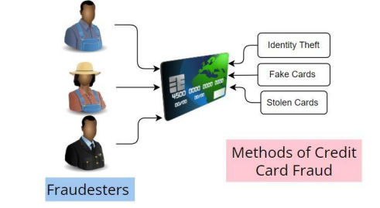
Fig. 1.1 Methods of Fraud Detection.
Machine learning represents a promising solution to deal with this problem [2]. Detecting fraudulent activities using traditional methods of manual detection is time-consuming and inefficient, moreover, the introduction of big data has made manual methods more unfeasible. Various limitations or challenges that are responsible for the difficulty in credit card detection are: a. Data sets are not easily accessible b. Imbalanced dataset c. Shaping the appropriate evaluation technique d. Vibrant behavior of fraudsters e. The size of the datasets Credit card fraud detection is the process of identifying transactions into two classes one is genuine/normal transactions, and the other is fraudulent transactions [3] [4]. There are mainly two types of credit card fraud, one is the theft of the physical card, and the other is stealing sensitive information from the card, such as accessing card numbers or account passwords, and then misusing this data for fraud. Many strategies can be used in the fraud detection process.
.

CHAPTER 2: LITERATURE REVIEW
A Deep Learning Ensemble With Data Resampling for Credit Card Fraud Detection
Date of Publication: 27 March 2023
Published By: IBOMOIYE DOMOR MIENYE AND YANXIA SUN
The authors stated that study develops a deep learning ensemble with data resampling for improved credit card fraud detection. The experimental results have been split into two, i.e., the classifiers’ performance before and after data resampling. Meanwhile, the proposed stacking ensemble was achieved using the LSTM and GRU neural networks as base learners and an MLP neural network as the meta-learner.

Credit Card Fraud Detection Using Supervised Learning Algorithms
Published By: Danilo Planinić ,Vesna Popović-Bugarin
Published in: 2024 28th International Conference on Information Technology (IT)Technologies and Internet of Things (IDCIoT)
This paper examines the performances of Logistic Regression, Random Forest, and CatBoost in the context of credit card fraud. The capability to handle imbalanced classes is evaluated for each algorithm, as well the impact of hyperparameter tuning on model performance. The findings reveal that algorithms based on decision trees effectively manage imbalances without need for additional data preprocessing.
Fraud Feature Boosting Mechanism and Spiral Oversampling Balancing Technique for Credit Card Fraud Detection
Published By: L Ni, J Li, H Xu, X Wang, J Zhang
Original Paper Published: International Conference on Research Methodologies in Knowledge
The authors says that credit card fraud detection model incorporating a fraud feature-boosting mechanism with a spiral oversampling balancing technique (SOBT). Specifically, we present a compound grouping elimination strategy to exclude highly redundant and correlated features from the credit card transaction dataset and improve the data quality.
.

CHAPTER 3: RESEARCH
3.1: STUDY
Credit card frauds are easy and friendly targets. E-commerce and many other online sites have increased the online payment modes, increasing the risk for online frauds. Increase in fraud rates, researchers started using different machine learning methods to detect and analyse frauds in online transactions. The main aim of the paper is to design and develop a novel fraud detection method for Streaming Transaction Data, with an objective, to analyse the past transaction details of the customers and extract the behavioural patterns.
3.2: SCOPE
This involves real-time monitoring of transactions for suspicious activity such as unusual spending patterns, large transactions, or transactions from unfamiliar locations. Utilizing advanced algorithms to analyze large volumes of data to detect patterns indicative of fraudulent behavior. These algorithms can adapt and learn from new fraud trends. Analyzing customer behavior over time to identify deviations from typical patterns, such as sudden changes in spending habits or unusual purchase locations. Verifying the identity of the cardholder through various methods such as biometrics, two-factor authentication, or knowledge-based authentication to prevent unauthorized use of credit cards. Developing and implementing rules and models based on historical fraud data and industry best practices to flag potentially fraudulent transactions for manual review. Overall, the scope of credit card fraud detection encompasses a wide range of techniques and technologies aimed at preventing, detecting, and mitigating fraudulent activity to safeguard both cardholders and financial institutions.

3.3: OBJECTIVES
- The primary objective is to accurately identify fraudulent transactions while minimizing false positives (legitimate transactions incorrectly flagged as fraudulent). Machine learning models aim to achieve high sensitivity (true positive rate) and specificity (true negative rate) to effectively distinguish between fraudulent and legitimate transactions.

- Machine learning models enable real-time or near-real-time detection of fraudulent activity, allowing financial institutions to promptly respond to suspicious transactions and mitigate potential losses.

- By automating the detection process using machine learning models, financial institutions can reduce the reliance on manual reviews for suspicious transactions, thereby improving operational efficiency and reducing costs.

- Machine learning-based fraud detection systems can scale to handle large volumes of transactions efficiently, making them suitable for processing the vast amounts of data generated by credit card transactions.

- Machine learning techniques allow for the identification of relevant features or variables that contribute to fraud detection. Additionally, interpretable models provide insights into the factors driving the classification of transactions as fraudulent or legitimate, aiding in model validation and regulatory compliance.

- Machine learning models can be designed to be robust against adversarial attacks aimed at circumventing fraud detection systems, ensuring that fraudsters cannot easily exploit vulnerabilities in the model.

- Machine learning-based fraud detection systems must comply with regulatory standards and guidelines such as the Payment Card Industry Data Security Standard (PCI DSS) to ensure the security and privacy of cardholder data.

- Continuous monitoring and evaluation of the performance of machine learning models enable ongoing refinement and optimization to adapt to evolving fraud threats and changes in transaction patterns.

CHAPTER 4: PROPOSED DESIGN
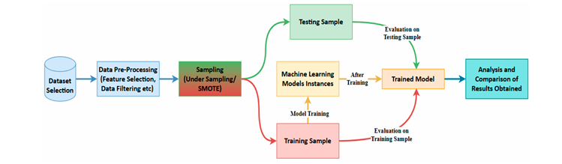
Fig.4.1 Flow chart of Proposed Work
Data Collection and Preprocessing: We begin by collecting a comprehensive dataset of credit card transactions, encompassing a diverse range of transactions, including both legitimate and fraudulent ones. Data preprocessing is then performed to clean, transform, and prepare the data for analysis. This step involves handling missing values, encoding categorical variables, and normalising features like transaction amounts and timestamps.
Feature Engineering: Feature engineering is a crucial aspect of our methodology. We craft meaningful features from the raw data to capture the nuances of credit card transactions. These engineered features may include transaction frequency, transaction amount percentiles, time-based features, and more. This step enhances the quality of input data for our models.
Anomaly Detection Models: Our methodology leverages various anomaly detection techniques, including supervised and unsupervised learning methods. Unsupervised models, such as Isolation Forest and One-Class SVM, are employed to identify anomalies in the data without the need for labelled examples. Supervised models, like Random Forest and Support Vector Machines, are also utilised, making use of historical fraud labels to train models for predictive accuracy.
Model Ensemble: In order to optimize detection precision and resilience, we employ model ensemble methodologies. These entail aggregating the results of several distinct models to reach a consensus. The system's overall performance and resistance to changing fraud patterns are improved by ensemble techniques like stacking and boosting.
Real-time scoring and alerting: Once our models are trained and deployed, they operate in real-time, continuously monitoring incoming transactions. When a transaction is flagged as potentially fraudulent, an alert is generated, and appropriate actions are taken. This real-time scoring ensures swift response and minimises potential financial losses.
Concept Drift Adaptation: Our methodology accounts for the evolving nature of fraud patterns, known as concept drift. We employ feedback mechanisms to monitor model performance over time and adapt to emerging fraud trends. Regular model retraining with updated data helps maintain high detection accuracy.
Model Evaluation and Metrics: A key component of our methodology is thorough model evaluation. We use a variety of evaluation metrics to evaluate the performance of the model, such as ROC-AUC, F1-score, precision, and recall. In order to guarantee robustness and validate the efficacy of the system, we also perform cross-validation.
Ethical Considerations: Ethical considerations are embedded throughout our methodology. We perform rigorous bias testing to mitigate discriminatory outcomes. Privacy and data protection are paramount, and user consent and transparency are foundational principles.

CHAPTER 5: IMPLEMENTATION

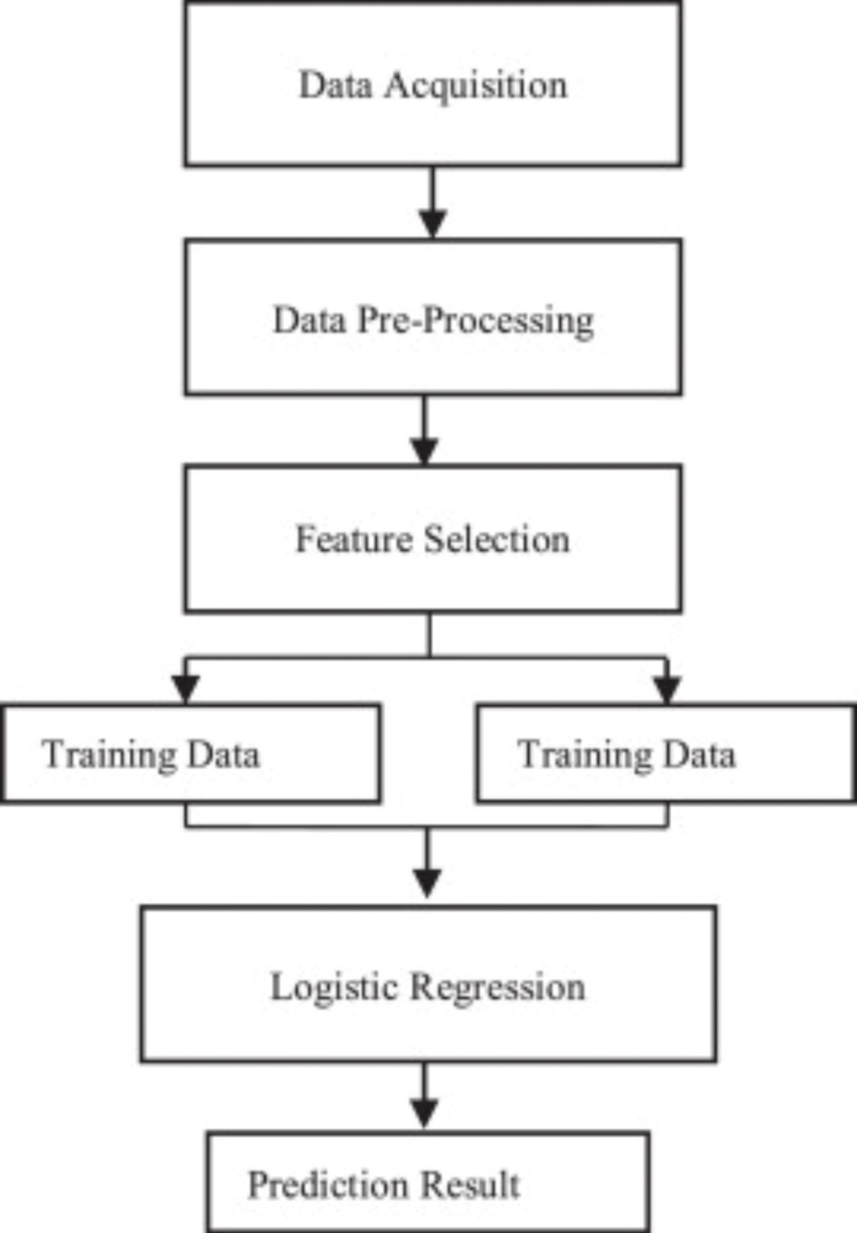
Fig 5.1 Implementation

Implementing detection algorithms is done in Python using various libraries like Pandas, NumPy, Matplotlib, Seaborn, Sklearn, and Imblearn. Credit card fraud detection is a classification problem, i.e., the class feature in the dataset represents whether a transaction is fraudulent or genuine. Supervised machine learning algorithms are used for implementation. This experiment was conducted in Jupyter, using the Anaconda platform. We have selected logistic regression, random forest, decision tree, and SVM for implementation and made a comparison on the basis of evaluation metrics. Logistic regression is a supervised learning model. It predicts the output of a binary dependent variable and one or more independent variables. Random forest algorithm is suitable for large datasets as it gives better predictions when there are more trees in the forest. Results are built for each decision tree in the forest, and then tree results are combined to get better predictions. Decision tree algorithms use the trees for predictions. The decision tree contains two nodes, namely decision nodes and leaf nodes. Decision nodes have multiple children and are used to make decisions, while leaf nodes have no children, which are the outcome of the decisions. It uses the features of the given dataset and predicts the outcomes. The support vector machine (SVM) algorithm is mostly used for classification problems. SVM chooses support vectors that help create hyperplane decision boundaries that segregate the data points into correct classes

CHAPTER 6: RESULT ANALYSIS
To determine the best-suited method for credit card fraud detection, the results are analyzed on the basis of the evaluation metrics, including confusion matrix, precision, recall, accuracy, f1-score, MCC, and AUC. Since we had split the dataset on a 0.2 ratio, i.e., the test dataset consists of 20% of the whole dataset, a total of 59692 samples. Hence of a total of 98 fraudulent transactions, the achieved results are depicted in confusion matrixes.
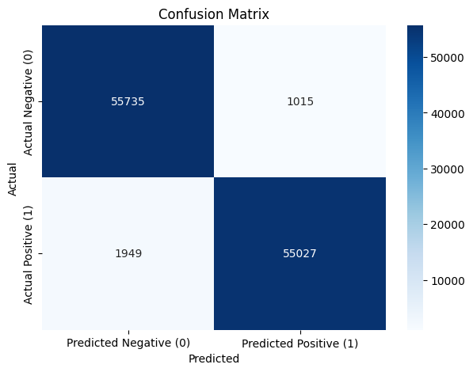
Fig 6.1 Confusion Matrix
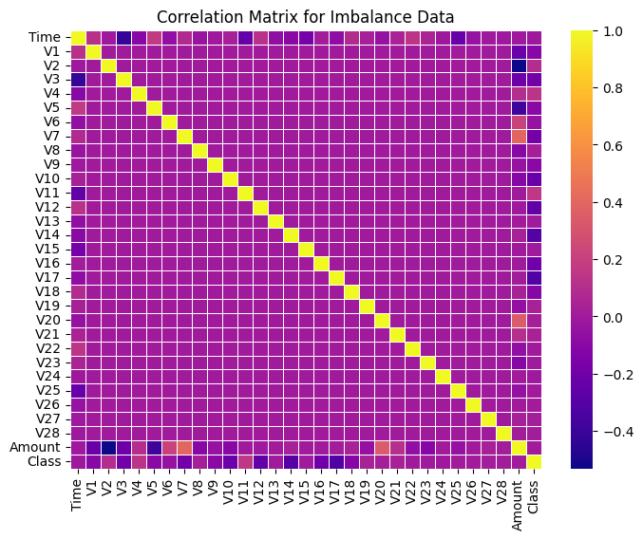
Fig. 6.2 Correlation Matric

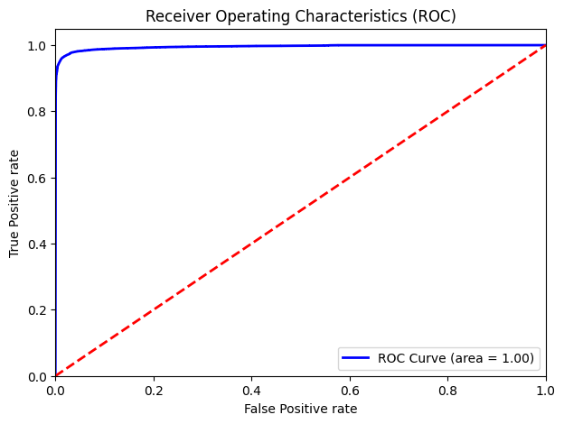
Fig 6.3 ROC

CHAPTER 7: CONCLUSION AND FUTURE WORK
In this paper we developed a novel method for fraud detection, where customers are grouped based on their transactions and extract behavioural patterns to develop a profile for every cardholder. Then different classifiers are applied on three different groups later rating scores are generated for every type of classifier. This dynamic changes in parameters lead the system to adapt to new cardholder's transaction behaviours timely.
Followed by a feedback mechanism to solve the problem of concept drift. We observed that the Matthews Correlation Coefficient was the better parameter to deal with imbalance dataset. MCC was not the only solution. By applying the SMOTE, we tried balancing the dataset, where we found that the classifiers were performing better than before. The other way of handling imbalance dataset is to use one-class classifiers like one-class SVM. We finally observed that Logistic regression, decision tree and random forest are the algorithms that gave better results.

REFERENCES
- Gupta, Shalini, and R. Johari. "A New Framework for Credit Card Transactions Involving Mutual Authentication between Cardholder and Merchant." International Conference on Communication Systems and Network Technologies IEEE, 2021: 22-26.
- L. Ni, J. Li, H. Xu, X. Wang and J. Zhang, "Fraud feature boosting mechanism and spiral oversampling balancing technique for credit card fraud detection", IEEE Trans. Computat. Social Syst., pp. 1-16, 2023.
- N. R. Dzakiyullah, A. Pramuntadi and A. K. Fauziyyah, "Semi-supervised classification on credit card fraud detection using autoencoders", J. Appl. Data Sci., vol. 2, no. 1, pp. 1-7, 2021.
- F. K. Alarfaj, I. Malik, H. U. Khan, N. Almusallam, M. Ramzan and M. Ahmed, "Credit card fraud detection using state-of-the-art machine learning and deep learning algorithms", IEEE Access, vol. 10, pp. 39700-39715, 2022.
- B. Prasetiyo, Alamsyah, M. A. Muslim and N. Baroroh, "Evaluation performance recall and F2 score of credit card fraud detection unbalanced dataset using SMOTE oversampling technique", J. Physics: Conf. Ser., vol. 1918, no. 4, Jun. 2021.
- Singh, R. K. Ranjan and A. Tiwari, "Credit card fraud detection under extreme imbalanced data: A comparative study of data-level algorithms", J. Experim. Theor. Artif. Intell., vol. 34, no. 4, pp. 571-598, Jul. 2022.
- N. S. Alfaiz and S. M. Fati, "Enhanced credit card fraud detection model using machine learning", Electronics, vol. 11, no. 4, pp. 662, Feb. 2022.
- Forough, J., & Momtazi, S. (2021). Ensemble of deep sequential models for credit card fraud detection. Applied Soft Computing, 99, 106883.

